**Copyright**

Insight by Grahame Knox is licensed under a Creative Commons Attribution-NonCommercial-No Derivative Works 3.0 Unported License.

Attribution-NonCommercial-NoDerivs 3.0 Unported (CC BY-NC-ND 3.0)



Lost at Sea



Grahame Knox

# Lost at Sea

You have chartered a yacht with three friends, for the holiday trip of a lifetime across the Atlantic Ocean. Because none of you have any previous sailing experience, you have hired an experienced skipper and two-person crew.

Unfortunately in mid Atlantic a fierce fire breaks out in the ships galley and the skipper and crew have been lost whilst trying to fight the blaze. Much of the yacht is destroyed and is slowly sinking.

Your location is unclear because vital navigational and radio equipment have been damaged in the fire. Your best estimate is that you are many hundreds of miles from the nearest landfall.

You and your friends have managed to save 15 items, undamaged and intact after the fire. In addition, you have salvaged a four-man rubber life craft and a box of matches.

Your task is to rank the 15 items in terms of their importance for you, as you wait to be rescued. Place the number 1 by the most important item, the number 2 by the second most important and so forth until you have ranked all 15 items.



# Instructions

1. Individually, and **without** discussing with others in the class, rank the 15 items, recording your scores in column 1 of the ranking sheet.

1. Ask each person to take 10 minutes to decide their own rankings, and record the choices in the left-hand **Step 1** column.

1. Get into teams of 3/4. Discuss your individual choices and work together to agree on a collaborative list. Record the group rankings in the second column (team rankings).

1. The ‘correct’ answers were suggested by the US Coastguard. Compare your individual and group answers with the correct answers and determine a score.

1. For each item, mark the number of points that your score differs from the Coastguard ranking and then add up all the points. Disregard plus or minus differences. The ***lower*** the total, the better your score**.**

1. Discuss with your group why the scores were different? What changed their minds? And was this enough to survive?

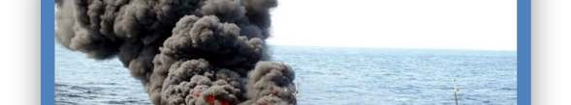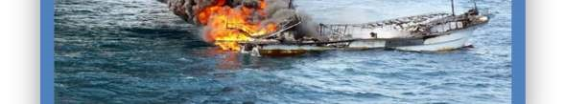

# Lost at Sea Ranking Chart

|  |  |  |  |  |  |
| --- | --- | --- | --- | --- | --- |
| **Items** | **Step 1** | **Step 2** | **Step 3** | **Step 4** | **Step 5** |
| Your individual ranking | Your team ranking | Coast Guard ranking | Difference between Step 1 & 3 | Difference between Step 2 & 3 |
| A sextant (tool for working out position) | **3** | **4** | **15** | **12** | **11** |
| A shaving mirror | 15 | **10** | **1** | **14** | **9** |
| A quantity of mosquito netting | **13** | **15** | **14** | **1** | **1** |
| A 25 litre container of water | **1** | **2** | **3** | **2** | **1** |
| A case of army rations | **2** | **5** | **4** | **2** | **1** |
| Maps of the Atlantic Ocean | **5** | **6** | **13** | **8** | **7** |
| A floating seat cushion | **14** | **12** | **9** | **5** | **3** |
| A 10 litre can of oil/petrol mixture | **12** | **7** | **2** | **10** | **5** |
| A small transistor radio | **4** | **1** | **12** | **8** | **11** |
| 20 square feet of opaque plastic sheeting | **9** | **9** | **5** | **4** | **4** |
| A can of shark repellent | **8** | **13** | **10** | **2** | **3** |
| One bottle of 160 proof rum | **6** | **3** | **11** | **5** | **8** |
| 15 feet of nylon rope | **10** | **14** | **8** | **2** | **6** |
| 2 boxes of chocolate bars | **11** | **8** | **6** | **5** | **2** |
| An ocean fishing kit & pole | **7** | **11** | **7** | **0** | **3** |
|  |  |  | **Totals** | **80** | **75** |